1 Introductions and Purpose of RDBMS

Overview
This presentation provides introduction to RDBMS.

Data and its Storage
Modern databases emerged somewhere in the 1960s. Computing power and storage had become much cheaper, making the use of computers for data indexing and storage a viable solution. There are 2 ways to store data in any computer
- Traditional Approach (File Systems)
- Database Management Systems (DBMS)
A File System is described by a very simple data storage model, where all the information is stored in a plain text file, one record per line. Each record is divided into fields using delimiters or at fixed column positions.

Drawbacks of File Systems
Drawbacks | Description
Data Dependency | All are dependent upon the data stored on the computer  As Data in traditional approach cannot be relied or dependent upon.  As Data inconsistency were more frequent in the traditional approach
Redundancy | Redundancy is the repetition of data  Data duplication was allowed in the traditional approach.  Data redundancy caused data inconsistency to occur in the data
Sharing | Data Sharing was difficult or impossible with traditional systems
Security | Data stored on the computer must be secured  To enforce independent information security was difficult with traditional approach.
Transaction Control | Transaction is unit of work  If one is performing some work ( for e.g. inserting some records) other persons should not be able to use that particular data  There was no way to isolate independent units of work in traditional approach

Table 1: Drawbacks of File Systems

Identifying Databases
The FreeOn-Line Dictionary of Computing defines a database as “one or more large structured sets of persistent data, usually associated with software to update and query the data. A simple database might be a single file containing many records, each of which contains the same set of fields where each field is a certain fixed width.”
A database consists of structured sets of data, which means that a database contains collections of data. Databases help you organize your data. The definition also says that databases are usually linked with software that allows the data to be updated and queried. Real – life examples of database software include Microsoft Access, Oracle 9i, IBM’s DB2 and Microsoft’s SQL Server 2000. They are database management systems. The definition states that a simple database might be just one file with many records with each record broken down into fields. A field is a single item of data about a specific thing. A thing could be a person, and a single item of data about a person could be his first name. Another item can be his address. Collectively these fields are known as a record. Each person has his own record, and all the records are stored collectively in a database in something called a table. A single database can contain multiple tables.
Few more definitions about data base
- DBMS is Data Base Management System
- It is a program that lets one or more computer users create and access data in a database
- It provides the definition, storage, and management of data in the centralized pool that can be shared by many users

Benefits of DBMS
There are many benefits of DBMS. They are as follows:
- Control Data Concurrency - Databases allow multiple users to access the same database simultaneously
- Avoid Data Redundancies - A properly set-up database minimizes data redundancy. It will avoid data repetition in the databases
- Ensure Data Validity - Databases allow you to set up rules that ensure that data remains consistent when add or modify data
- Ensure Data Sharing - Sharing data is also easier in database
- Ensure Data Security - Advantage of databases is security
A database is used to
- Allow Data Dependency
- Allow Data Sharing
- Avoid data redundancies
- Allow Data Sharing
- Ensure Security
- Ensures Data Validity

Databases allow you to set up rules that ensure that data remains consistent when add or modify data.
Example: Imagine that a department has two employees named Ramesh Tiwari. You can set up a database to ensure that each employee has unique ID, called a unique identifier (so that same names don’t get mixed up).

A properly set-up database minimizes data redundancy.
Using the Employee example, you can store all the details of an employee just once in the database and use a unique ID to identify each employee. When you have other data that relates to a particular employee (for example, which department he is working), you can use the unique ID to search for the data.

Sharing data is also much easier using a database. We can share data among a number of users on the same computer or among users on different computers linked via a network or the Internet. Databases also allow more than one person to access the database at the same time and change the data stored; the database management system handles simultaneous changes.

One final advantage of databases is security. Most database management systems allow you to create users in order to indicate various levels of security. Before someone accesses the database, he or she must log on as a specific user. Each user has various rights and limits. Someone who maintains the database has full ability to edit data, modify the database’s structure, add and delete users, and so on. Other users may only have the ability to view data but not change it, or you may even want to limit what data they can view. Many database management systems provide a granular level of security, that is, they are very specific as to what a user can do.

Application program using DBMS Services
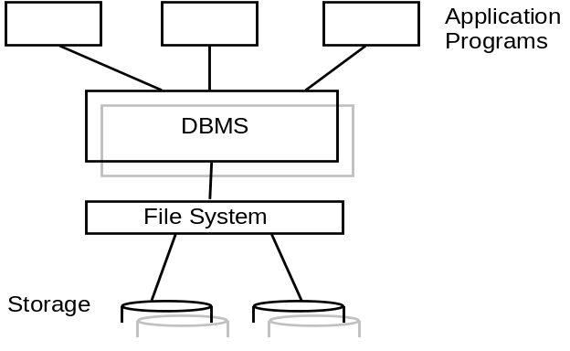
Figure 1 – Application program using DBMS Services

This diagram shows how application programs interact with the DBMS. DBMS actually is a repository of data which provide information to the application programs as well as storing information from the application programs.
This is a typical example of a client-server system, where different application programs will access the DBMS via network.
All the applications will access only one database.
The DBMS is physically stored as Files in the Hard Disk of the system.

Multitier Architecture
Multi-tier architecture (often referred to as n-tier architecture) is a client-server architecture in which an application is executed by more than one distinct software agent.
For example, an application that uses middleware to service data requests between a user and a database employs multi-tier architecture.
The most widespread use of "multi-tier architecture" refers to three-tier architecture.

Three-tier Architecture
In computing, Three-tier is a client-server architecture in which the user interface, functional process logic ("business rules"), data storage and data access are developed and maintained as independent modules, most often on separate platforms.
The term "three-tier" or "three-layer", as well as the concept of multitier architectures, seems to have originated within Rational Software.
The three-tier model is considered to be software architecture and a software design pattern.
Apart from the usual advantages of modular software with well defined interfaces, the three-tier architecture is intended to allow any of the three tiers to be upgraded or replaced independently as requirements or technology change. For example, a change of desktop operating system from Microsoft Windows to Unix would only affect the user interface code.
Typically, the user interface runs on a desktop PC or workstation and uses a standard graphical user interface, functional process logic may consist of one or more separate modules running on a workstation server or application server, and an RDBMS on a database server or mainframe contains the data storage logic. The middle tier may be multi-tiered itself (in which case the overall architecture is called an "n-tier architecture").
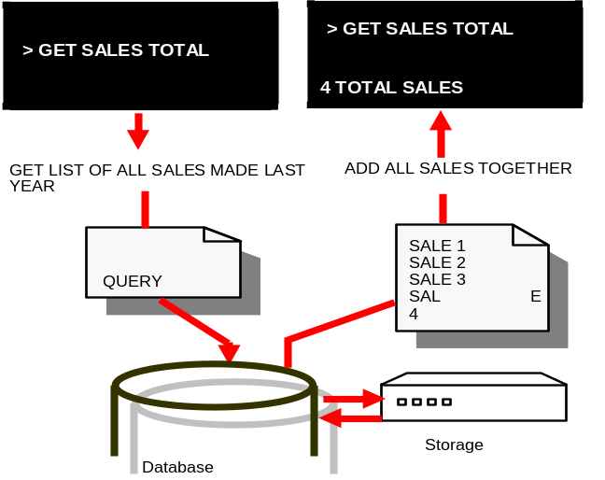
Figure 2: Illustration for three-tier Architecture

Presentation Tier
The top-most level of the application is the user interface. The main function of the interface is to translate tasks and results to something the user can understand.

Logic Tier
This layer coordinates the application, processes commands, makes logical decisions and evaluations, and performs calculations. It also moves and processes data between the two surrounding layers.

Data Tier
Here Information is stored and retrieved from a database or file system. The information is then passed back to the logic tier for processing, and then eventually back to the user.

Data Models
A data model is a model that describes in an abstract way how data is represented in a business organization, an information system or a database management system.
This term is ambiguously defined to mean:
how data generally is organized, e.g. as described in Database management system. This is sometimes also called "database model" or
how data of a specific business function is organized logically (e.g. the data model of some business)
There are basically 3 classic data Models
- Hierarchical Data Model
- Network Data Model
- Relational Data Model

Hierarchical Data Model
It is best suitable for data’s which are in some way hierarchically related. It explicitly makes use of the hierarchies by providing a tree by which all data are accessible. The tree consists of a root representing the highest level in the hierarchy, sub-trees representing intermediate levels of the hierarchy, and leaves containing the actual data. Between tree nodes of consecutive levels, there is a ``father-son"-relationship: each node can have n child nodes which, in turn, can be father nodes of sub-trees. In hierarchical data models, each child node can only have one father node. The links between the nodes of the tree are realized by pointers. Hierarchical data base models offer a very efficient access along the links of the tree, thus through the hierarchy.

Network Data Model
The network model is a database model conceived as flexible way of representing objects and their relationships. Its original inventor was Charles Bachman, and it was developed into a standard specification published in 1969 by the CODASYL Consortium. Where the hierarchical model structures data as a tree of records, with each record having one parent record and many children, the network model allows each record to have multiple parent and child records, forming a lattice structure.
The principal argument in favor of the network model, in comparison to the hierarchic model, was that it allowed a more natural modeling of relationships between entities. Although the model was widely implemented and used, it failed to become dominant for two major reasons. Firstly, IBM chose to stick to the hierarchical model in their established products such as IMS and DL/I. Secondly, it was eventually displaced by the relational model, which offered a higher-level, more declarative interface.

Relational Data Model
The relational model was introduced by Dr. E. F. Codd in 1970 and has evolved since then, through a series of writings. The model provides a simple, yet rigorously defined, concept of how users perceive data. The relational model represents data in the form of two-dimensional tables. Each table represents some real-world person, place, thing, or event about which information is collected. A relational database is a collection of two-dimensional tables. The organization of data into relational tables is known as the logical view of the database. That is, the form in which a relational database presents data to the user and the programmer.

Type of Data Model | Description
Hierarchical Model | Well suited for data which are related hierarchically
Network Model | Database model conceived as flexible way of representing objects and their relationships
Relational Model | Data is represented in the form of two-dimensional tables

Table 2: Different Types of Data Models

Features of Relational Model
The relational model of data permits the database designer to create a consistent, logical representation of information. Consistency is achieved by including declared constraints in the database design, which is usually referred to as the logical schema.
The basic relational building block is the domain or data type. A tuple is an unordered set of attribute values. An attribute is an ordered pair of attribute name and type name. An attribute value is an ordered pair of attribute and value, the value being of the type of the attribute.
A relation consists of a heading and a body. A heading is a set of attributes. A body (of an n-ary relation) is a set of n-tuples. A relation consists of a heading and a body. The heading of the relation is also the heading of each of its tuples.
The concept of the relation as a set of unordered n-tuples is the distinguishing feature of the relational model. In mathematics the relation is a set of ordered n-tuples. It was one of E.F. Codd's great insights that using attribute names instead of an ordering would be so much more convenient, in general, in a computer language based on relations. An immediate and important consequence of this distinguishing feature is that in the relational model Cartesian product becomes commutative.
A table is an accepted visual representation of a relation; a tuple is similar to the concept of row, but note that in the database language SQL the columns of a table are ordered.
A relvar (relation variable) is a named variable of some specific relation type, to which at all times some relation of that type is assigned.
The basic principle of the relational model is the Information Principle: all information is represented by data values in relations. In accordance with this Principle, a relational database is a set of relvars and the result of every query is presented as a relation.
The consistency of a relational database is enforced, not by rules built into the applications that use it, but rather by constraints, declared as part of the logical schema and enforced by the DBMS for all applications.
Now we discuss the Codd’s rules. Database Management Systems must adhere to Codd’s rules in order to be termed as RDBMS.
- It is based on Relational algebra i. e. mathematical theory of relations
- It was first described by E.F. Codd in 1970 and then modified by IBM
- It presents data in form of tables
- Rules of Relational Data Model
      - It defines tables which contains Rows and Columns
      - It presents a set of rules to ensure the integrity of the database
      - In Relational model a table is also a relation
      - Row is known as a tuple
      - Column is known as an attribute
- Dr. Codd modified his model by defining 12 rules (Codd’s Rules), that a DBMS must meet in order to be considered a relational database
Note: In practice, many database products (for e.g. Oracle, Sybase etc..) are considered 'relational' even if they do not strictly adhere to all 12 rules.

Basic Terms and Definition
There are few common terminologies used in database. They are as follows
- The term 'database' has many interpretations - one definition is a 'collection of persistent data'
- A relational database is one in which the data consists of a 'collection of tables related to each other through common values'
- A relational database management system (RDBMS) uses matching values in multiple tables to relate the information in one table with the information in the other table
- The presentation of data as tables is a logical construct - it is independent of the way the data is physically stored on disk
- The two most prominent characteristics of a relational database are
  - Data stored in tables
  - Relationships between tables
- A table (entity or relation) is a collection of rows and columns
- A row (record or tuple) represents a collection of information about a separate item (e.g., a customer)
- A column (field or attribute) represents the characteristics of an item (e.g., the customer's name or phone number)
- A relationship (join) is a logical link between two tables

Codd’s 12 rules
Codd's Rule #1 : Information rule
A set of related tables forms a database and all data is represented as tables, the data can be viewed in no other way.

Codd's Rule #2 : Guaranteed Access Rule
Each value can be accessed by specifying table name, primary key and column name. This way each and every value is uniquely identifiable and accessible.
Basically this is a restatement of the fundamental requirement for primary keys.
A relational database does not reference data by physical location, there is no such thing as the ‘fifth row in the customers table'.
Each piece of data must be logically accessible by referencing
1) a table
2) a primary or unique key value and
3) a column.
Codd's Rule #3 : Systematic Treatment of NULL values
Null must always be interpreted as an unknown value.
Codd's Rule #4.
Dynamic on-line catalog based on the relational model
In addition to user data, a relational database contains data about itself.
There are two types of tables in a RDBMS: user tables that contain the 'working' data and system tables contain data about the database structure.
Metadata is data that describes the structure of the database itself and includes object definitions (tables, indexes, stored procedures, etc.) and how they relate to each other.
The collection of system tables is also referred to as the system catalog or data dictionary.

Codd's Rule #5 : Comprehensive Data Sublanguage Rule
There must be a single language that handles all communication with the database management system.
The language must support relational operations with respect to: data modification (i.e., SELECT, INSERT, UPDATE, DELETE), data definition (i.e., CREATE, ALTER, DROP) and administration (i.e., GRANT, REVOKE, DENY, BACKUP, RESTORE).
Structured Query Language (SQL) is the de facto standard for a relational database language.
SQL is a ‘nonprocedural’ or ‘declarative’ language; it allows users to express what they want from the RDBMS without specifying the details about where it's located or how to get it.

Codd’s Rule #6 : View Updating Rule
A relational database must not be limited to source tables when presenting data to the user. Data can be presented to the user in different logical combinations, called views
Views are virtual tables or abstractions of the source tables.
Views allow the creation of ‘custom tables’ that are tailored to special needs.
In practice, providing update and delete access to logical views is difficult and is not fully supported by any current database.

Codd's Rule #7 : High-level insert, update and delete
Rows are treated as sets for data manipulation operations (SELECT, INSERT, UPDATE, DELETE).
A relational database must support basic relational algebra operations (selection, projection; & join ) and set operations (union, intersection, division, and difference).
Set operations and relational algebra are used to operate on 'relations' (tables) to produce other relations.
A database that supports only row-at-a-time (navigational) operations does not meet this requirement and is not considered 'relational'.
Codd's Rule #8 : Physical Data Independence
Applications that access data in a relational database must be unaffected by changes in the way the data is physically stored (i.e., the physical structure).

Codd's Rule #9 : Logical Data Independence
The database schema or structure of tables and relationships (logical) can change without having to recreate the application that uses it.

Codd's Rule #10 : Integrity Independence
In order to be considered relational, data integrity must be an internal function of the DBMS; not the application program.
Data integrity means the consistency and accuracy of the data in the database (i.e., keeping the garbage out of the database).

Codd's Rule #11: Distribution Independence
The data manipulation (sub) language of the RDBMS should be able to work with distributed databases.
Views should be able to join data from tables on different servers (distributed queries) as well as from different RDBMS (heterogeneous queries).
The user should not have to be aware of whether a database is distributed or not.
Data in a relational database can be stored centrally or distributed. Users can join data from tables on different servers (distributed queries) and from other relational databases (heterogeneous queries).
Data integrity must be maintained regardless of the number of copies of data and where it resides.

Codd's Rule #12: Non subversion Rule
There cannot be other paths into the database that subvert data integrity; in other words, you can't get in the 'back door' and change the data in such a manner as data integrity is violated.

